**DEVELOP A WEB APPLICATION USING NODE-RE**

|  |  |
| --- | --- |
| Date | 01 November 2022 |
| Team ID | **PNT2022TMID11798** |
| Project Name | Project – IOT Based Real – time River  Water Quality Monitoring and Control System |
| Maximum Marks | 4 Marks |

1. Double-click the tab with the flow name, and call it Earthquake Details.

1. Click the hamburger menu, and then click **Manage palette**. Look for **node-red-node- open weather map** to install these additional nodes in your palette.

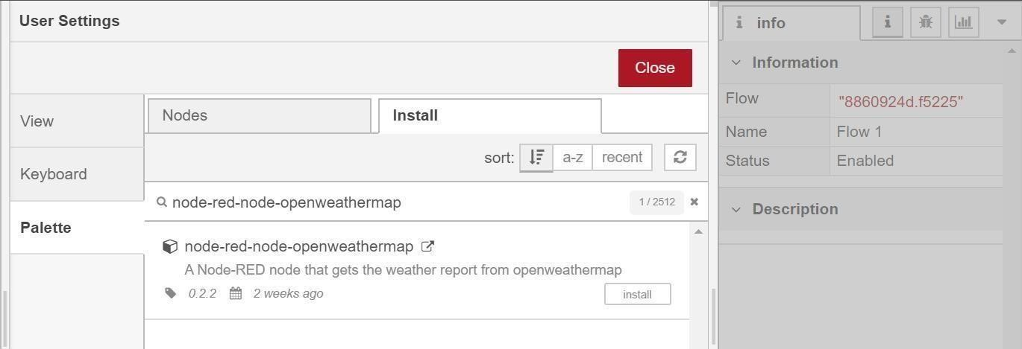

Add an **HTTP input** node to your flow.

Double-click the node to edit it. Set the method to GET and set the URL to /earthquakeinfo-hr.

* 1. Add an **HTTP response** node, and connect it to the previously added **HTTP input** node.All other nodes introduced in this sub-section is to be added between the **HTTP input** node and the **HTTP response** node.
  2. Add an **HTTP request** node and setthe *URL* to

https://earthquake.usgs.gov/earthquakes/feed/v1.0/summary

/all_hour.geojson, the *Method* to **GET** and the *Return* to **a parsed JSON object**. This will allow extracting all earthquakes that occurred within the last hour. Name this node Get

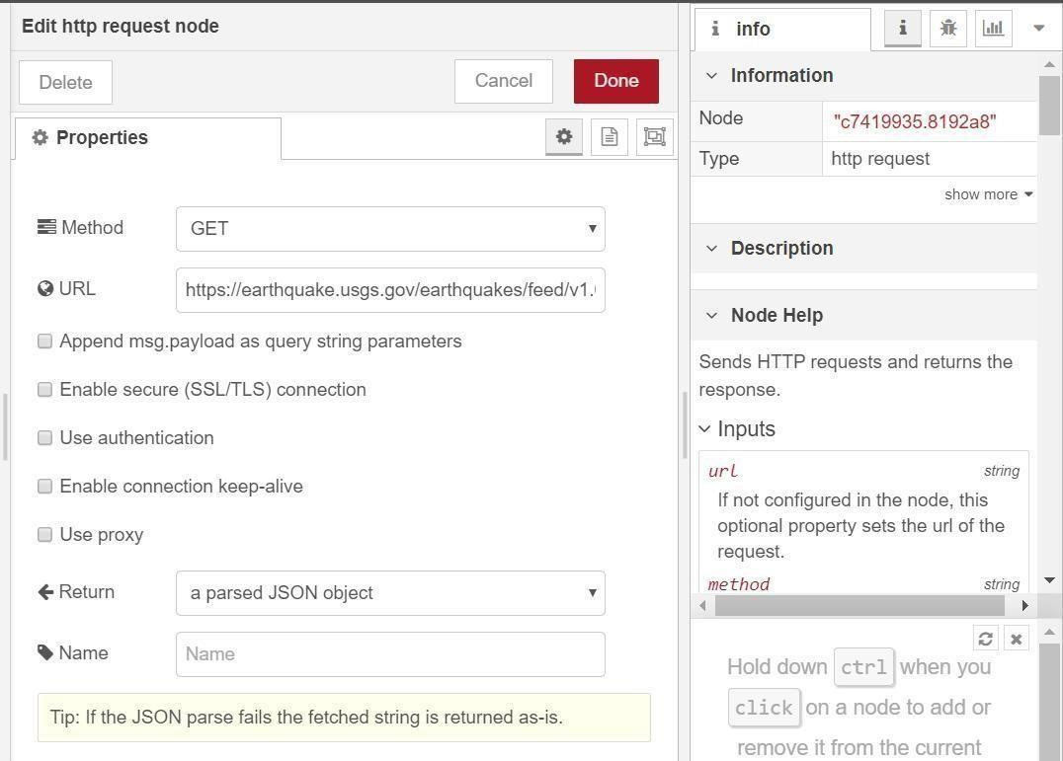

|  |  |  |  |
| --- | --- | --- | --- |
| Add a **change** node. Double-click the node to modify it. Name this node Set Earthquake  Info. In | | |  |
| the **Rules** section, add rul to *Delete* msg.topic, | | es | |
| msg.headers, msg.statusCode, msg.responseUrland msg.redirectLis | |
| t and *Set*  msg.payloa | d payload.features. | | |
| {  "type":properties.type,  "magnitude": properties.mag,  "location": properties.place,  "longitude":geometry.coordinates[0],  "latitude":geometry.coordinates[1],  "depth":geometry.coordinates[2],  "timestamp": $fromMillis(properties.time, | | | |